OSPA OOSC
Breakfast and After School Club

Sports

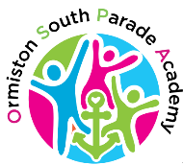
School Library
Films

Arts & Crafts
Games

ICT

Please contact the school Office for more information
01472 231659

Breakfast Activity Club After School
£3.50 £4.00 £7.50
8.00am – 8.45am 3.15pm – 4.45pm 3.15pm – 6.00pm

