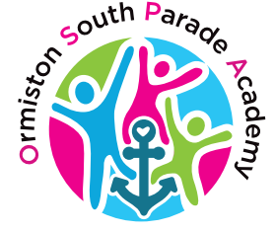
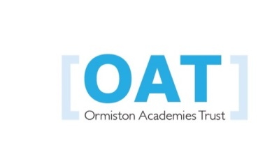
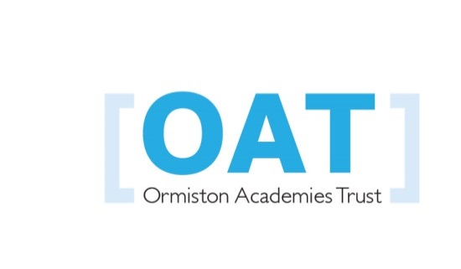

Ormiston South Parade Academy

Charging and Remissions
Policy

Date reviewed: 25th June 2026 Next review date: 24th June 2027

Policy prepared by | OSPA
Responsible committee
Date approved by committee
Date ratified by LGB (if required)
Description of changes from the model policy (if any)

1 Introduction

All education during school hours is free. We do not charge for any activity undertaken as part of the National Curriculum with the exception of individual or group music tuition.

2.1 Voluntary Contributions

When organising school trips or visits which enrich the curriculum and educational experience of the children, OSPA invites parents to contribute to the cost of the trip. All contributions are voluntary. If we do not receive sufficient voluntary contributions, we may cancel a trip. If a trip goes ahead, it may include children whose parents have not paid any contribution. We do not treat these children differently from any others.

If a parent wishes for their child to take part in a school trip or event, but is unwilling or unable to make a voluntary contribution, we do allow the child to participate fully in the trip or activity. In the majority of cases OSPA pays additional costs in order to support the visit.

The following is a list of additional activities organised by OSPA, which require voluntary contributions from parents. This list is not exhaustive:
- visits to museums
- visits which require transport to or from the venue
- sporting activities which require transport expenses
- outdoor adventure activities
- visits to the theatre
- musical events

2.2 Residential Visits

If OSPA organises a residential visit in school time or mainly school time, which is to provide education directly related to the National Curriculum, we do not make any charge for this. However, we do make a charge to cover the costs of board and lodging as well as transport costs.

2.3 Tuition in the Playing of a Musical Instrument

All children study music as part of the normal school curriculum. We do not charge for this. There is a charge for individual or group music tuition if this is not part of the National Curriculum. The peripatetic music teachers teach individual or small group lessons. We make a charge for these lessons. We give parents information about additional music tuition at the start of each academic year.

The Academy reserves the right to provide sponsorship for a child to pursue musical
gifts and talents, by having music lessons paid for by OSPA.

2.4 Swimming

OSPA organises swimming lessons for all children in Key Stage 2, usually in Year 4. These take place in school time and are part of the National Curriculum. We make no charge for this activity. We ask for a voluntary contribution towards the cost of the coach to and from lessons. We inform parents when these lessons are to take place and we ask parents for their written permission for their child to take part in swimming lessons.

2.4 After School Activities

OSPA offers a wide variety of after school activities. We make a small charge for these sessions if they are run by external providers.

2.5 Before and After School Childcare

OSPA runs a breakfast and after school club on site for academy pupils. This is a fee paying service as it is outside of the academy’s educational activities. Fees for this are reviewed annually.

2.6 Early Years Snacks

We provide children in Nursery with ‘help yourself’ snacks. For children not eligible for Early Years Pupil Premium we request a contribution towards the purchase of the provision

2.7 Breakages

Parents/carers may be asked to pay for the cost of replacing broken windows or damaged books etc., when this is as a result of pupils’ behaviour.

2.8 Private Use of Academy Facilities

Governors delegate the responsibility for determining charges for the private use of Academy facilities by members of staff, for example, private telephone calls, reprographics to the Principal.

